Tenda AC10-how to change the WiFi Name and Password?
Model Number: Tenda AC10
Question Classification: Function Setting

Step 1: Open a browser and type http://tendawifi.com in Address Bar, tap “Enter”. Input login password and tap “Login”.

Step 2: Tap “WiFi Settings”, select “WiFi Name & Password”.

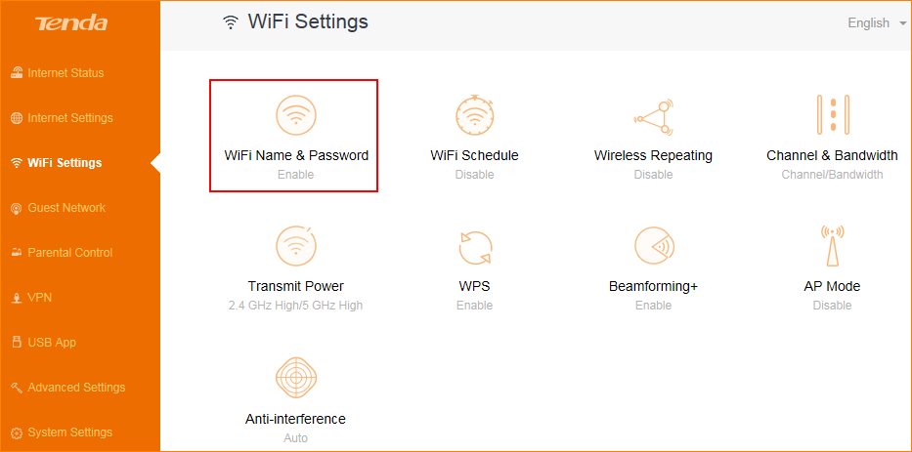

Step 3: Modify the WiFi Name and Password, then tap “Save”.

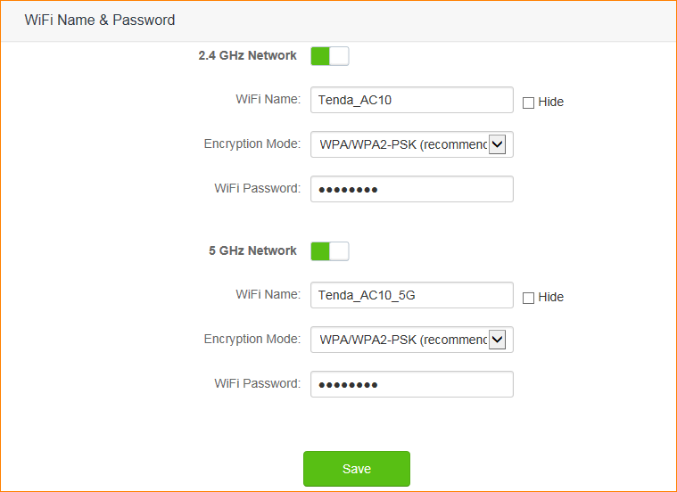

Note:
- When the WiFi Name and Password has being changed, the WiFi will be disconnected, you should reconnect new wifi name with new password you set.
- When you change the WiFi Password, it is recommended to modify the WiFi Name at the same time.

